Supporting information for:
MuSR revealing sodium ion mobility in hard carbon anodes before and after sodiation
Anders C. S. Jensen^{a,b}, Kirstin I. E. Olsson^{b,c}, Heather Au^{b}, Maria-Magdalena Titirici^{b} and Alan J. Drew*ª

ªSchool of Physics and Astronomy, Queen Mary University of London, SW7 2AZ London, United Kingdom, ^{b}Department of Chemical Engineering, Imperial College London, Mile End Road, E1 4NS London, United Kingdom
*corresponding author: Email: a.j.drew@qmul.ac.uk
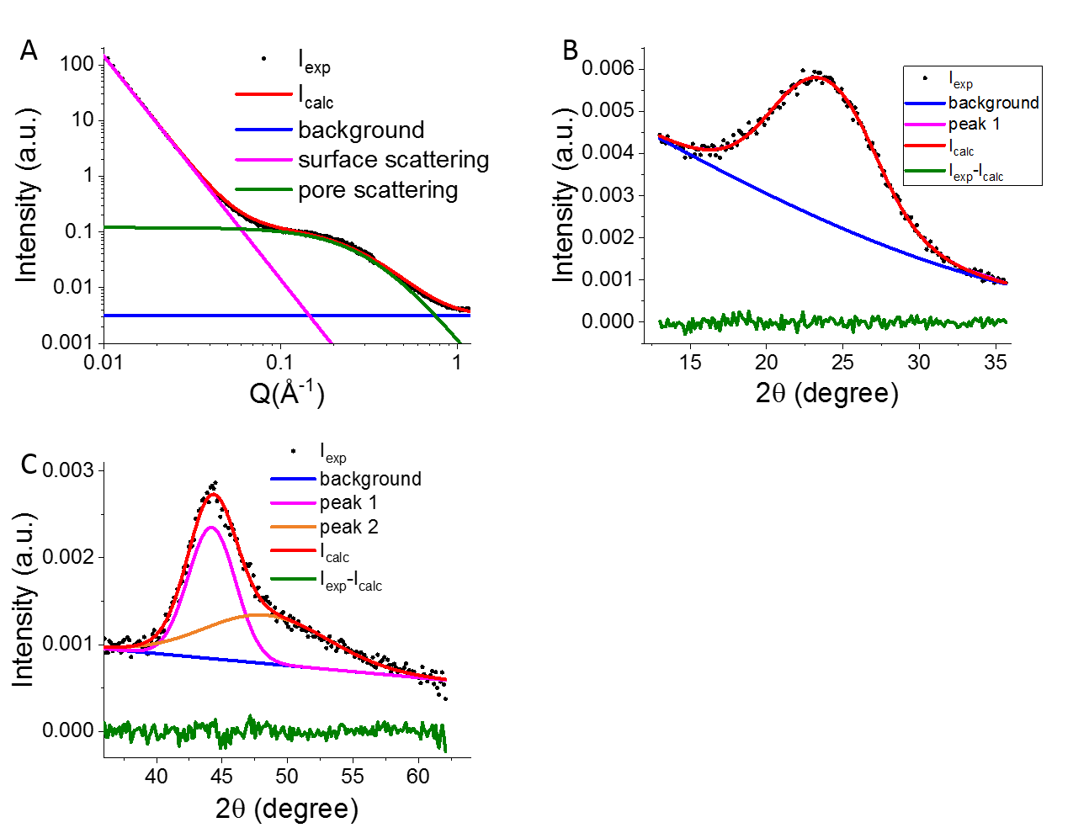
Figure S1: A) SAXS region fitted using a pored equation as described by Stevens and Dahn 2000¹ fitting the surface scattering (pink) and the scattering from the nano pores(green).
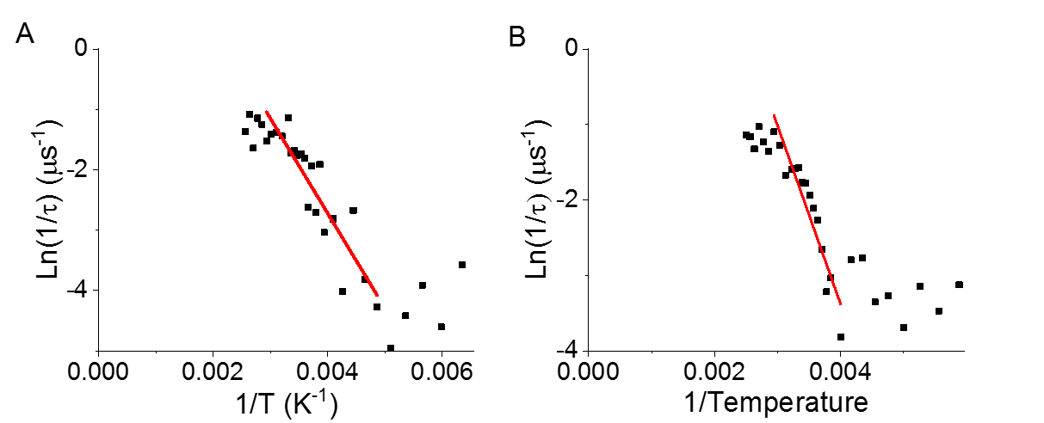
Figure S2: Arrhenius plot of the jump frequency and temperature for the sodiated(A) and desodiated samples(B).

1. Stevens, D. A.; Dahn, J. R., An In Situ Small‐Angle X‐Ray Scattering Study of Sodium Insertion into a Nanoporous Carbon Anode Material within an Operating Electrochemical Cell. Journal of The Electrochemical Society 2000, 147 (12), 4428-4431.

